**TED Talk. How to Make Stress your Friend[1]**

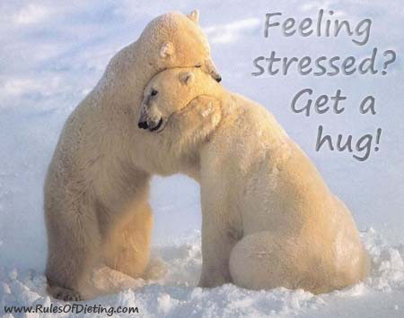

**SPEAKING**

1. **Discuss with your partner**
2. What images pop up in your mind when you hear the word “stress”?
3. Are you stressed at the moment?
4. What stresses you out?
5. How do you deal with stress?
6. Can stress be positive?
7. **Describe a stressful day. You should say[2]:**

* how the day started
* how things went wrong
* who the people involved were

and explain why it was stressful.

**VOCABULARY**

1. **Before you watch. Complete the sentences with the words below.**

***cuddle to nudge to harass to prime hype compassionate pituitary gland***

1) The experimenter has been trained ____________ you during the test.

2) Oxytocin has already got as much ________________ as a hormone can get.

3) It even has its own cute nickname, the _____________ hormone, because it's released when you hug someone.

4) Your _______________ pumps this hormone out as part of the stress response.

5) This hormone _______________ you to do things to strengthen relationship.

6) Your biological stress response is _____________ you to tell someone how you feel, instead of bottling it up.

7) Some people have even suggested we should snort oxytocin to become more __________ and caring.

1. **Match the beginnings of the following collocations with their endings. Watch the video and check your work.**

|  |  |
| --- | --- |
| 1) your heart | a) constrict |
| 2) your blood vessels | b) of the stress |
| 3) to get rid | c) empathy |
| 4) to fine-tune | d) is pounding |
| 5) to enhance | e) effect |
| 6) to bottle | f) social instincts |
| 7) to have anti-inflammatory | g) stress-induced damage |
| 8) to heal from | h) up feelings |

**VIEW**

1. **Answer the questions:**

1) What good and bad news does the speaker talk about?

2) How does the human body usually respond to stress?

3) How does the physical response change if the stress perception becomes positive?

4) Which aspect of stress response is under-appreciated?

5) What functions does oxytocin fulfill? Why does it enhance stress resilience?

6) What’s the role of social interaction in handling stress effectively?

**SPEAKING**

1. **Discuss with your partner[3]:**

1) What is the main idea of the video? Does it make sense to you?

2) When was the most stressful time of your life? What did you learn anything from that experience?

3) Which would you choose: a stressful job with very high pay or a relaxing job with considerably low pay? Why?

4) Is being single less stressful than married life? What are the advantages and disadvantages of each?

5) Is life becoming more or less stressful?

**WRITING**

1. **Write an essay about the following topic[4]:**

Stress is now a major problem in many countries around the world. What are some of the factors in modern society that cause this stress, and how can we reduce it?

**Give reasons for your answer and include any relevant examples from your own knowledge or experience.**

1. <https://www.ted.com/talks/kelly_mcgonigal_how_to_make_stress_your_friend>
2. <http://www.ielts-mentor.com/cue-card-sample/666-ielts-cue-card-sample-56-describe-a-stressful-day-at-school-university-work>
3. <http://iteslj.org/questions/stress.html>
4. <http://www.ieltsbuddy.com/stress-essay.html>